A Report on

**CHATBOT FOR MRCET**

Submitted by

M.Prajwal :- 20N31A1297

K.Sai pranay :- 20N31A1291

P.Omkar :- 20N31A12B8

Faculty Incharge

A.Vijetha

**Application Development-I**

**Department of Information Technology**

**MallaReddy College of Engineering and Technology**

(Autonomous Institution- UGC, Govt. of India)

(Affiliated to JNTUH, Hyderabad, Approved by AICTE, NBA &NAAC with ‘A’Grade)

Maisammaguda, Kompally, Dhulapally, Secunderabad – 500100 website: [www.mrcet.ac.in)](http://www.mrcet.ac.in/)

Table of Contents

|  |  |  |
| --- | --- | --- |
| S.no | Content | Page |
| 1 | Introduction | 3 |
| 2 | Application Description | 4-13 |
| 3 | Results | 14-16 |
| 4 | Conclusion/Future Enhancements | 17 |
| 5 | References | 18 |

**1.Introduction**

A chatbot is an artificial intelligence (AI) software that can simulate a conversation (or a chat) with a user in natural language through messaging applications, websites, mobile apps or through the telephone.A chatbot is often described as one of the most advanced and promising expressions of interaction between humans and machines. However, from a technological point of view, a chatbot only represents the natural evolution of a Question Answering system leveraging Natural Language Processing (NLP). Formulating responses to questions in natural language is one of the most typical Examples of Natural Language Processing applied in various enterprises’ end-use applications. We are aiming to build an automatic chatbot for answering college-related queries that are frequently asked by students. Students have a lot of queries and the queries are quite varied. They need answers to their queries quickly but, this is not possible as they need to browse through the entire website or approach Admins, which is both time taking and cumbersome.

Hence to facilitate this process, we need to automate this process. Our chatbot will serve this purpose efficiently by giving the most appropriate answers to the queries in the blink of an eye. Nowadays, we see the chat bots everywhere Chat bots are the source of answers to the users’ questions in any domain where it is operating.Chat bots are the source of answers to the users’ questions in any domain where it is operating.The AI chatbot can interpret human language as it is written, which enables them to operate more or less on their own.It can understand language outside of pre-programmed commands and provide a response based on existing data.It is a computer program designed to simulate a conversation with human users, over the internet.

**2.Application Description:**

Welcome to the College Chatbot, an AI-powered virtual assistant designed to assist college students with a wide range of queries and concerns related to their academic journey.

Our chatbot is built to be user-friendly and accessible to all students, whether they are freshmen or seniors. The chatbot is available 24/7 and can be accessed through various platforms like the college website, mobile applications, and social media channels.

Here are some of the features and benefits of our College Chatbot:

1. Personalized Assistance: Our chatbot provides personalized assistance to students by answering their queries based on their specific needs and preferences. This includes questions related to course scheduling, exam dates, registration, and enrollment, among others.

2. Resourceful: The chatbot is equipped with a vast database of information and resources, including course catalogs, academic calendars, student policies, and financial aid information. This ensures that students have easy access to the information they need to succeed academically.

3. Accessibility: The chatbot is designed to be accessible to all students, including those with disabilities. It can be easily integrated with screen readers and other assistive technologies, ensuring that every student can access the information they need.

4. Convenience: The chatbot is available 24/7, which means that students can access it at any time and from anywhere. This eliminates the need for students to wait in long lines or make phone calls to get their queries answered.

In conclusion, our College Chatbot is an innovative solution that aims to enhance the overall academic experience of college students. With its user-friendly interface and personalized assistance, it is the perfect tool for students who want to stay on top of their academic journey.

**Source Code:**

1. **DATA COLLECTION:**

The dataset has been acquired by scrapping the college website pages such as the admissions page of MRCET, the Reddit page dedicated to MRCET, and all the questions related to MRCET from website and assembling them.

{"intents": [

{"tag": "greeting",

"patterns": ["Hi there", "How are you", "Is anyone there?","Hey","Hola", "Hello", "Good day","hey","whatsup"],

"responses": ["Hello", "Hi,Good to see you again", "Hi there, how can I help?","hello welcome"],

"context": [""]

},

{"tag": "goodbye",

"patterns": ["Bye", "See you later", "Goodbye", "Nice chatting to you, bye", "Till next time"],

"responses": ["See you!", "Have a nice day", "Bye! Come back again soon."],

"context": [""]

},

{"tag": "thanks",

"patterns": ["Thanks", "Thank you", "That's helpful", "Awesome, thanks", "Thanks for helping me"],

"responses": ["Happy to help!", "Any time!", "My pleasure"],

"context": [""]

},

{"tag": "ET-department",

"patterns": ["who is the HOD of cse-ds","who is the hod of IOT","who is the hod of CSE-CS","who is the head for Emerging technologies","who is the hod for ET-department" ],

"responses": ["Dr.M. V. Kamal\nHOD-Allied Branches of CSE"],

"context": [""]

},

{"tag": "IT-department",

"patterns": ["who is the HOD of IT department","it hod"],

"responses": ["Dr.G.Sharadha\n HOD of IT"],

"context": [""]

},

{"tag": "CSE-department",

"patterns": ["who is the HOD of CSE department" ],

"responses": ["Dr.S.Shanthi\nHOD of CSE"],

"context": [""]

},

{"tag": "ECE-department",

"patterns": ["who is the HOD of ECE department"],

"responses": ["Dr.K.Mallikarjuna Lingam\nHOD of ECE"],

"context": [""]

},

{"tag": "EEE-department",

"patterns": ["who is the HOD of EEE department"],

"responses": ["Dr.M.Sharanya\nHOD of EEE"],

"context": [""]

},

{"tag": "departments",

"patterns": ["what courses are available","what courses are provided in the institute","department names","what are the departments","tell me about the departments","what are the available departments"],

"responses": ["Humanities and Sciences(H&S)\n Aeronautical Engineering\n Artificial Intelligence & Machine learning\n Artificial Intelligence & DataScience\n CSE-computer science and engineering\n CSE-artificial intelligence & machine learning\n CSE-data science\n CSE-internet of things\n CSE-cyber security\n electronics & communication engineering\n electrical & electronics engineering\n information technology\n mechanical engineering\n master of business administration\n M.Tech courses"],

"context": [""]

},

{"tag": "Principal",

"patterns": ["who is the principal of mrcet?","Principal of the college"],

"responses": ["Dr. S Srinivasa Rao is the principal of MRCET"],

"context": [""]

},

{"tag": "Admission",

"patterns": ["What is the admission process of mrcet?","admission process","fee details","process of admission","admission"],

"responses": ["for the details please visit https://mrcet.com/Programmes.html"],

"context": [""]

},

{"tag": "Timings",

"patterns": ["What are the college timings?","college timing","what is the college working timings?"],

"responses": ["The college working houres are from 9:30am to 4:00pm \n Monday-Saturday"],

"context": [""]

},

{"tag": "New courses",

"patterns": ["what are the new courses in college?","new courses"],

"responses": ["Data science \n Cyber Security \n AIML \n IOT \n AI-DS \n AI"],

"context": [""]

},

}

]

**DATA PRE-PROCESSING:**

import nltk

from nltk.stem import WordNetLemmatizer

lemmatizer = WordNetLemmatizer()

import json

import pickle

import numpy as np

from keras.models import Sequential

from keras.layers import Dense, Activation, Dropout

from keras.optimizers import SGD

import random

importing the required modules for processing of the data.

**Tokenizing:** Tokenizing is the process of splitting a stream of texts like sentences into smaller chunks(tokens) like words.

for intent in intents['intents']:

    for pattern in intent['patterns']:

        #tokenize each word

        w = nltk.word_tokenize(pattern)

        words.extend(w)

        #add documents in the corpus

        documents.append((w, intent['tag']))

        # add to our classes list

        if intent['tag'] not in classes:

            classes.append(intent['tag'])

**Lemmatization:** Lemmatization is the process of reducing words into their root words and ensures that the word is meaningful form.

# lemmaztize and lower each word and remove duplicates

words = [lemmatizer.lemmatize(w.lower()) for w in words if w not in ignore_words]

words = sorted(list(set(words)))

# sort classes

classes = sorted(list(set(classes)))

# documents = combination between patterns and intents

print (len(documents), "documents")

# classes = intents

print (len(classes), "classes", classes)

# words = all words, vocabulary

print (len(words), "unique lemmatized words", words)

pickle.dump(words,open('words.pkl','wb'))

pickle.dump(classes,open('classes.pkl','wb'))

**TRANING DATASET:**

# create our training data

training = []

# create an empty array for our output

output_empty = [0] * len(classes)

# training set, bag of words for each sentence

for doc in documents:

    # initialize our bag of words

    bag = []

random.shuffle(training)

training = np.array(training)

# create train and test lists. X - patterns, Y - intents

train_x = list(training[:,0])

train_y = list(training[:,1])

print("Training data created")

**MODEL BUILDING**

We will use TensorFlow’s Keras function to create a model. We will use Dropout to prevent overfitting between layers.

# Create model - 3 layers.

model = Sequential()

model.add(Dense(128, input_shape=(len(train_x[0]),), activation='relu'))

model.add(Dropout(0.5))

model.add(Dense(64, activation='relu'))

model.add(Dropout(0.5))

model.add(Dense(len(train_y[0]), activation='softmax'))

sgd = SGD(lr=0.01, decay=1e-6, momentum=0.9, nesterov=True)

model.compile(loss='categorical_crossentropy', optimizer=sgd, metrics=['accuracy'])

#fitting and saving the model

hist = model.fit(np.array(train_x), np.array(train_y), epochs=200, batch_size=5, verbose=1)

model.save('chatbot_model.h5', hist)

print("model created")

**USER INTERFACE:**

we will utilise Python’s Tkinter module to create a graphical user interface.

#Creating GUI with tkinter

import tkinter

from tkinter import *

def send():

    msg = EntryBox.get("1.0",'end-1c').strip()

    EntryBox.delete("0.0",END)

    if msg != '':

        ChatLog.config(state=NORMAL)

        ChatLog.insert(END, "You: " + msg + '\n\n')

        ChatLog.config(foreground="#33ff33", font=("Verdana", 12 ))

res = chatbot_response(msg)

        ChatLog.insert(END, "Bot: " + res + '\n\n')

        ChatLog.config(state=DISABLED)

        ChatLog.yview(END)

base = Tk()

base.title("MRCET BOT")

base.geometry("400x500")

base.resizable(width=FALSE, height=FALSE)

#Create Chat window

ChatLog = Text(base, bd=0, bg="#000000", fg="#33ff33",height="8", width="50", font="Arial",)

ChatLog.config(state=DISABLED)

#Bind scrollbar to Chat window

scrollbar = Scrollbar(base, command=ChatLog.yview, cursor="heart")

ChatLog['yscrollcommand'] = scrollbar.set bd=0, bg="#1c2e44", activebackground="#3c9d9b",fg='#33ff33',

command= send )

#Create the box to enter message

EntryBox = Text(base, bd=0, bg="#000000",width="29", height="5",fg='#33ff33', font="Arial")

#EntryBox.bind("<Return>", send)

#Place all components on the screen

scrollbar.place(x=376,y=6, height=386)

ChatLog.place(x=6,y=6, height=386, width=370)

EntryBox.place(x=128, y=401, height=90, width=265)

SendButton.place(x=6, y=401, height=90)

base.mainloop()

**3.Results:**

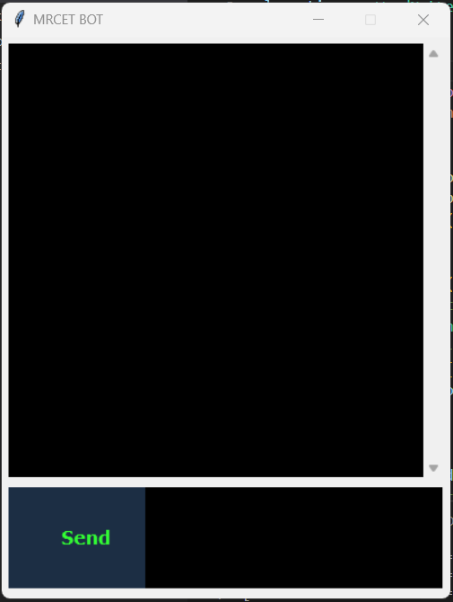Basic interface:

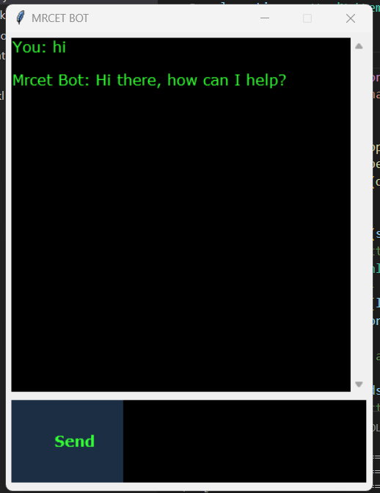

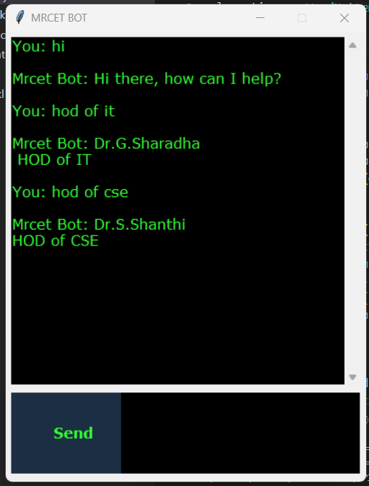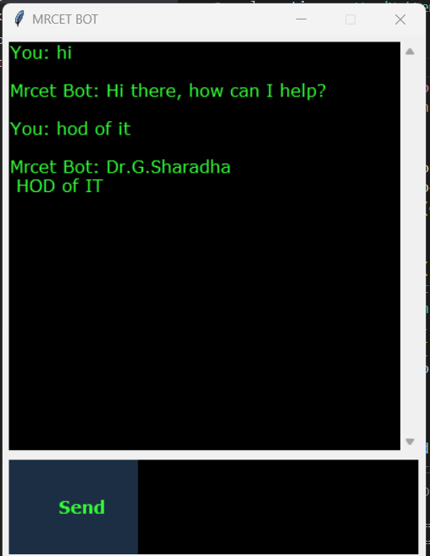

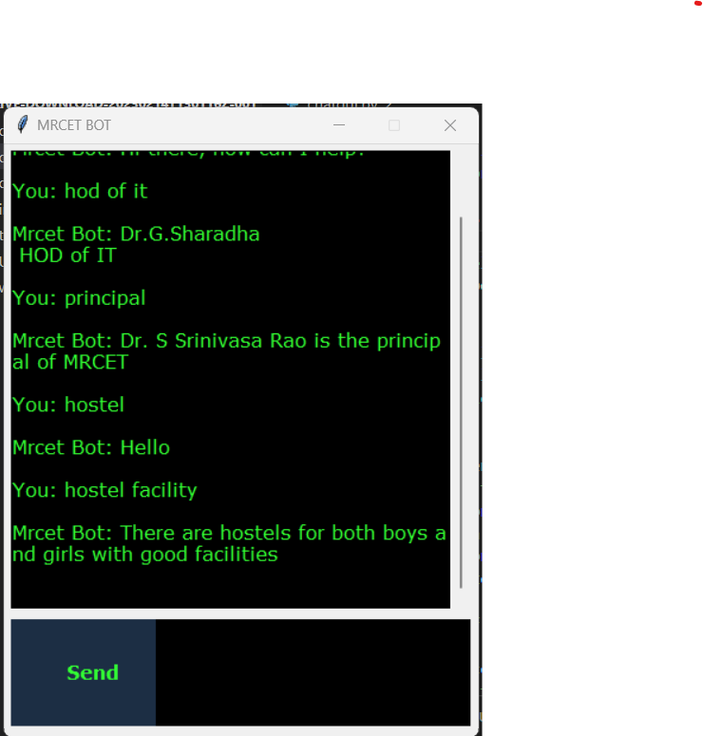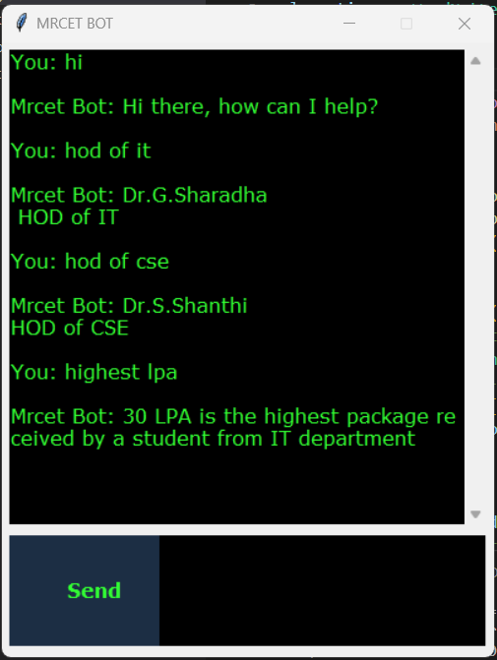

# Conclusion/Future Enhancements :

In this project we made a college specific chatbot system that can be custom fitted to education domain chatbot, the addition of this chatbot system in the college website will make the webpage more user interactive as it responds to the user queries very accurately as it is a domain specific chatbot system, and furthermore we had investigated our college chatbot system design stages and a few different techniques by which the precision of the chatbot system can be made much better. To make the responses given by the chatbot system more meaningful and accurate the administrator must train the chatbot system with more information regarding to college and increase the scope of knowledge base.

# References :

1. The Anatomy of A.L.I. CE: Dr. Richard S. Wallace http://www.alicebot.org/anatomy.html.
2. Prof.K. Bala, Mukesh Kumar, SayaliHulawale, Sahil Pandita, “Chat-Bot for College Management System Using A.I” International Research Journal of Engineering and Technology (IRJET) Volume: 04, Issue: 11, Page no: 2030-2033| Nov 2017
3. Amey Tiwari, Rahul Talekar, Prof.S.M. Patil, “College Information Chat Bot System” International Journal of Engineering Research and General Science (IJERGS) Volume: 5, Issue: 2, Page no: 131-137| March-April 2017

1. Word Net Algorithm, Available at https://wordnet.princeton.edu/.

1. Setiaji Bayu, Wibowo Ferry “Chatbot Using a Knowledge in Database: Human-to-Machine Conversation Modelling” 7th International Conference on Intelligent Systems, Modelling and Simulation (ISMS) Page no: 72-77| Jan 2016. DOI: 10.1109/ISMS.2016. 53..

1. Guruswami Hiremath, Aishwarya Hajare, Priyanka Bhosale, RasikaNanaware, Dr. K. S. Wagh, “Chatbot for education system” International Journal of Advance Research, Ideas and Innovations in Technology (IJARIIT) ISSN: 2454-132X, Volume: 4, Issue: 3, Page no: 37-43|2018...